**CH1 AN INTRODUCTION TO THE HUMAN BODY**

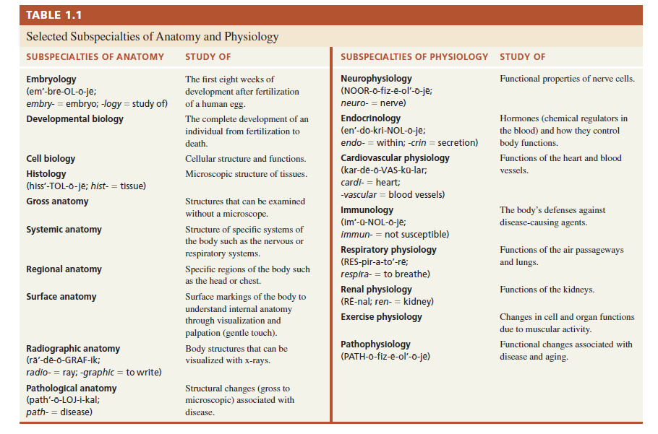

Checkpoint:

1. What body function might a respiratory therapist strive to improve? What structures are involved?

A respiratory therapist works to improve the gas exchange of CO2 for O2. The structures involved include: nasal passages, mouth, throat, (airway management), larynx, pharynx, trachea, lungs, alveoli, bronchial tubes and to some extent the heart. All structures are part of the respiratory process to some degree. Balancing the acid-base make up is also part of the respiratory therapist concern if the respiratory system is compromised.

1. Give your own example of how the structure of a part of the body is related to its function.

Skull/Cranial Cavity holds the actual brain structure in place and protects the brain from injury and to some degree the cerebral spinal fluid.

1. Define the following terms: atom, molecule, cell, tissue, organ, system, and organism.

a. Atoms: smallest unit of matter. Found at chemical level of structural hierarchy

b. Molecule: 2 or more atoms combined. Still in the chemical level of structural hierarchy

c .Cell: Combination of molecules. Basic structural and functional level of an organism. This is the smallest LIVING units in the human body.

d. Tissue: This is a group of cells and their surrounding materials that work as a group for a specific function.

e. Organ: Different tissues combined to form structures with specific functions. Some organs do belong to more than one system